**WRONG**

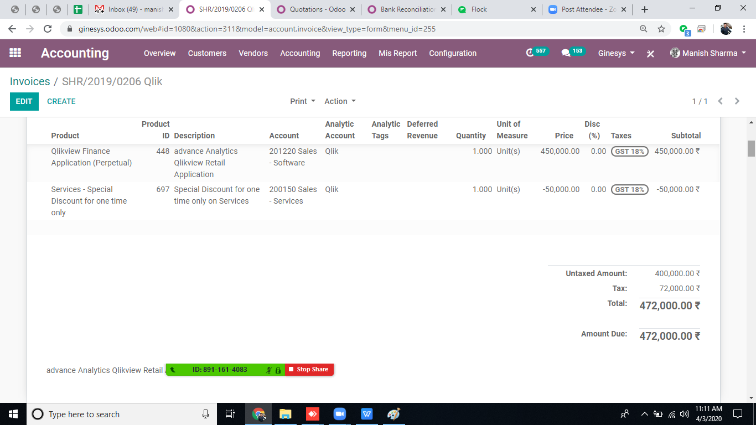

**Corrected**

**As there is no product of Application discount in qlik, so you can use same product with negative amount of discount,**

